**Supporting Information for**

**An atlas of human viruses provides new insights into diversity and tissue tropism of human viruses**

**Supplementary Figures**

**Figure S1** Source of viruses used in this study.

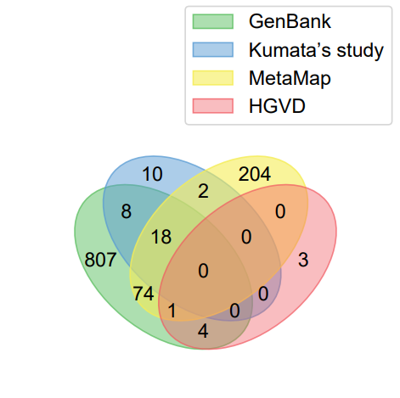

**Figure S2** Viral family composition of viruses used in this study.

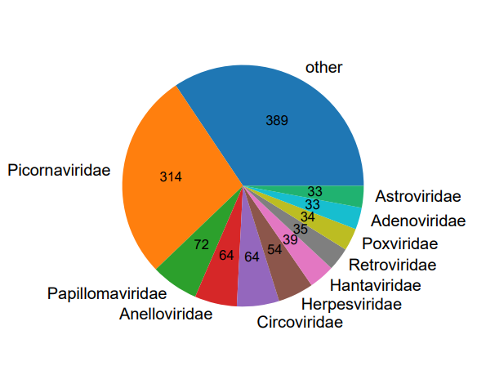

**Figure S3** The number of viral species per sample in males and females. ns, no significant difference. N, the number of samples used in the analysis.

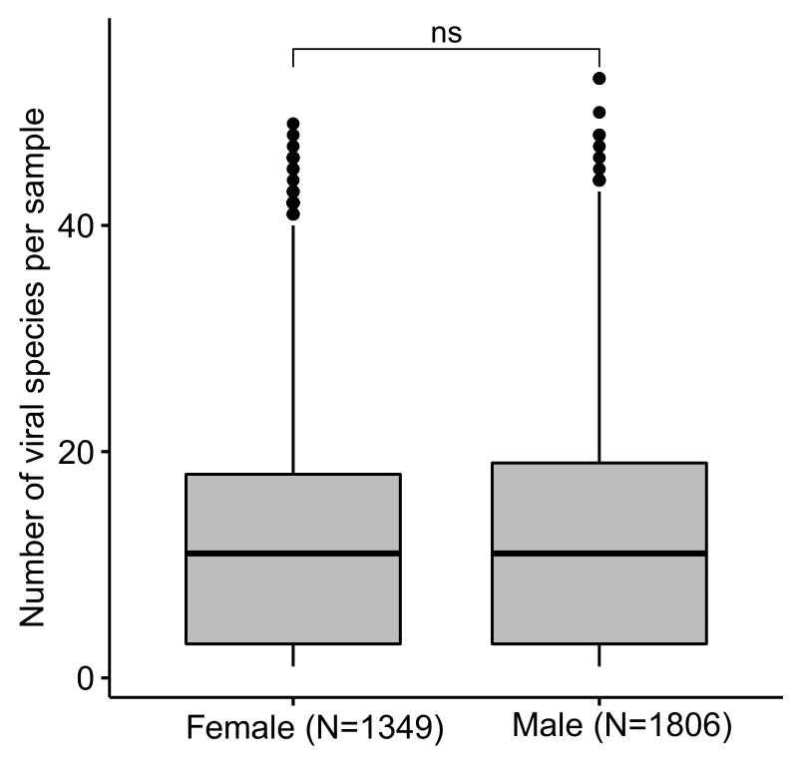

**Figure S4** The composition of viral families detected in samples of males and females.

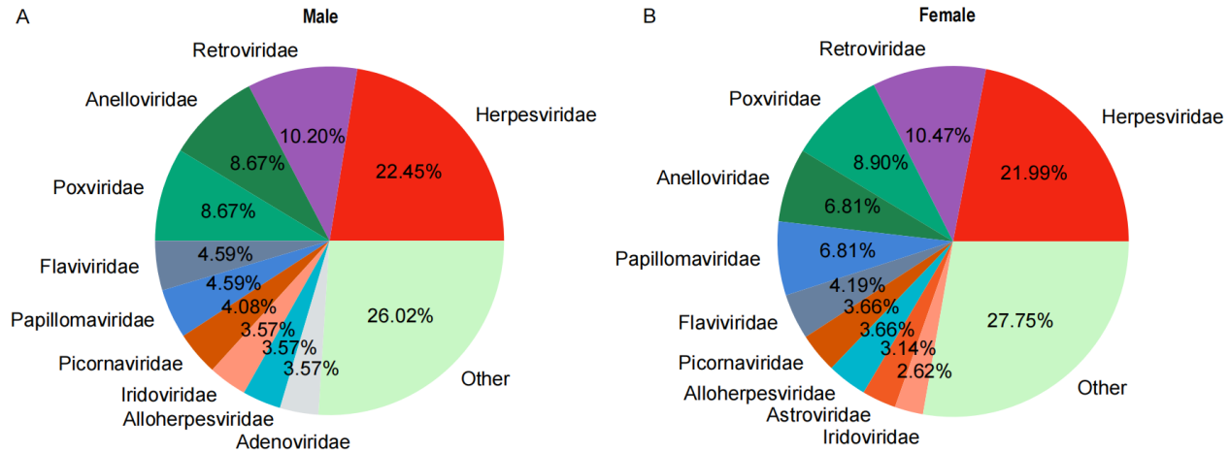

**Figure S5 T**he composition of viral families detected in samples of different life stages.

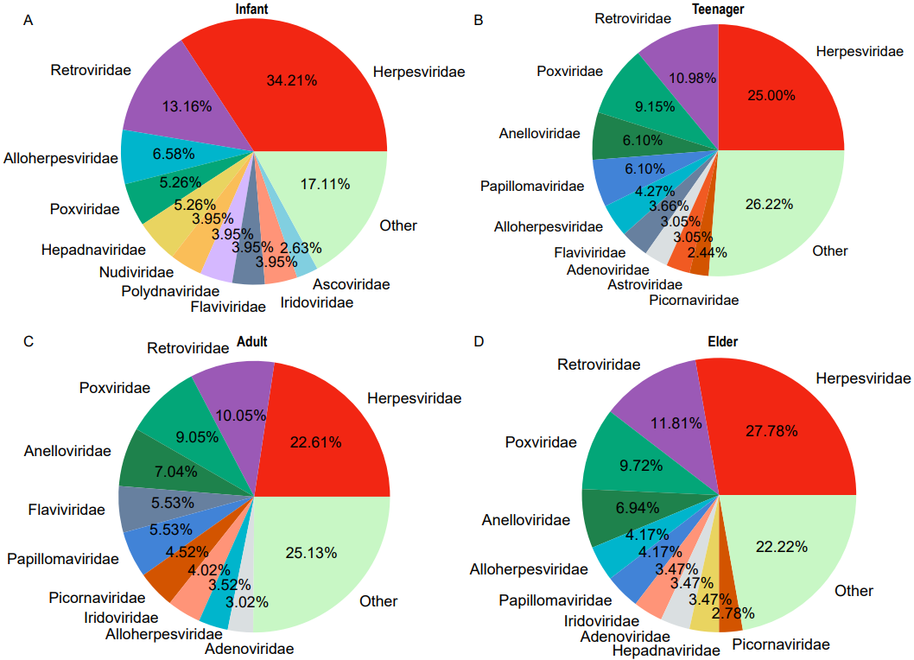

**Figure S6** The relationship between the GC content of viral genomic sequences and the number of tissues infected by all viruses (A), RNA viruses (B) and reverse-transcribing viruses (C). N, the number of samples used in the analysis.

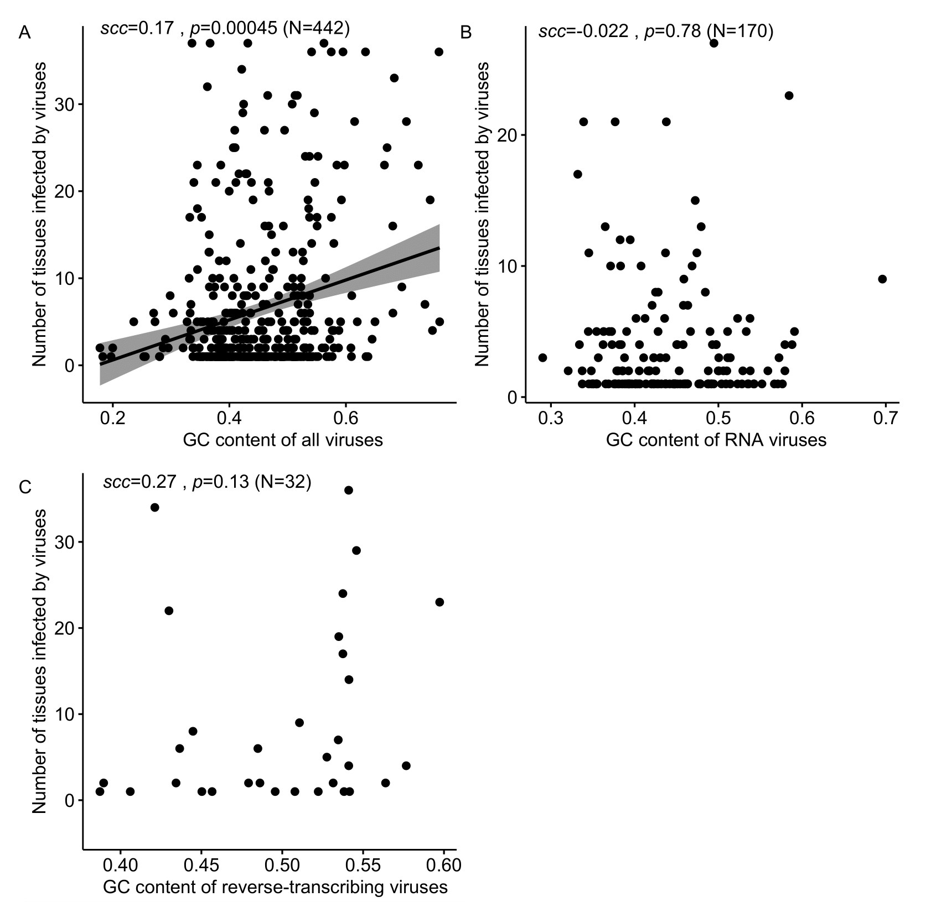

**Figure S7** The relationship between the genome length and the number of tissues infected by all viruses (A), RNA viruses (B) and reverse-transcribing viruses (C). N, the number of samples used in the analysis.

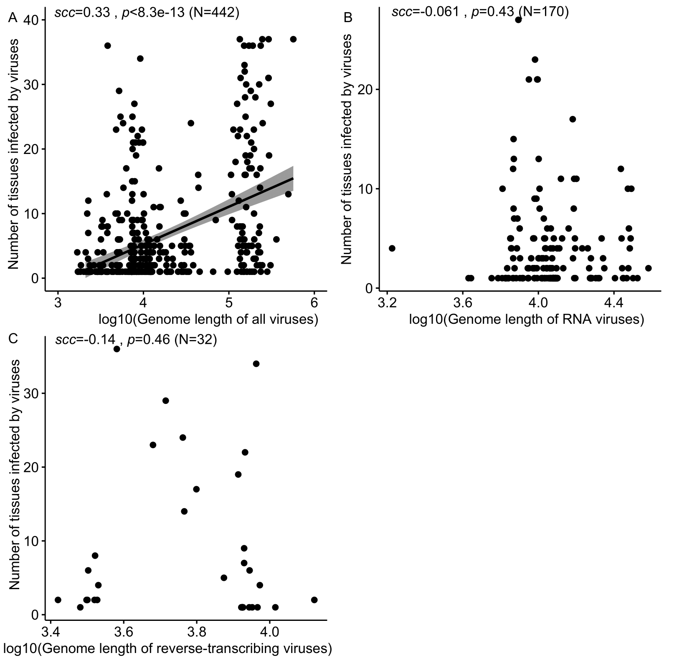

**Figure S8** The relationship between the number of viral receptors and the number of tissues infected by all viruses (A), RNA viruses (B) and reverse-transcribing viruses (C). N, the number of viruses used in the analysis.

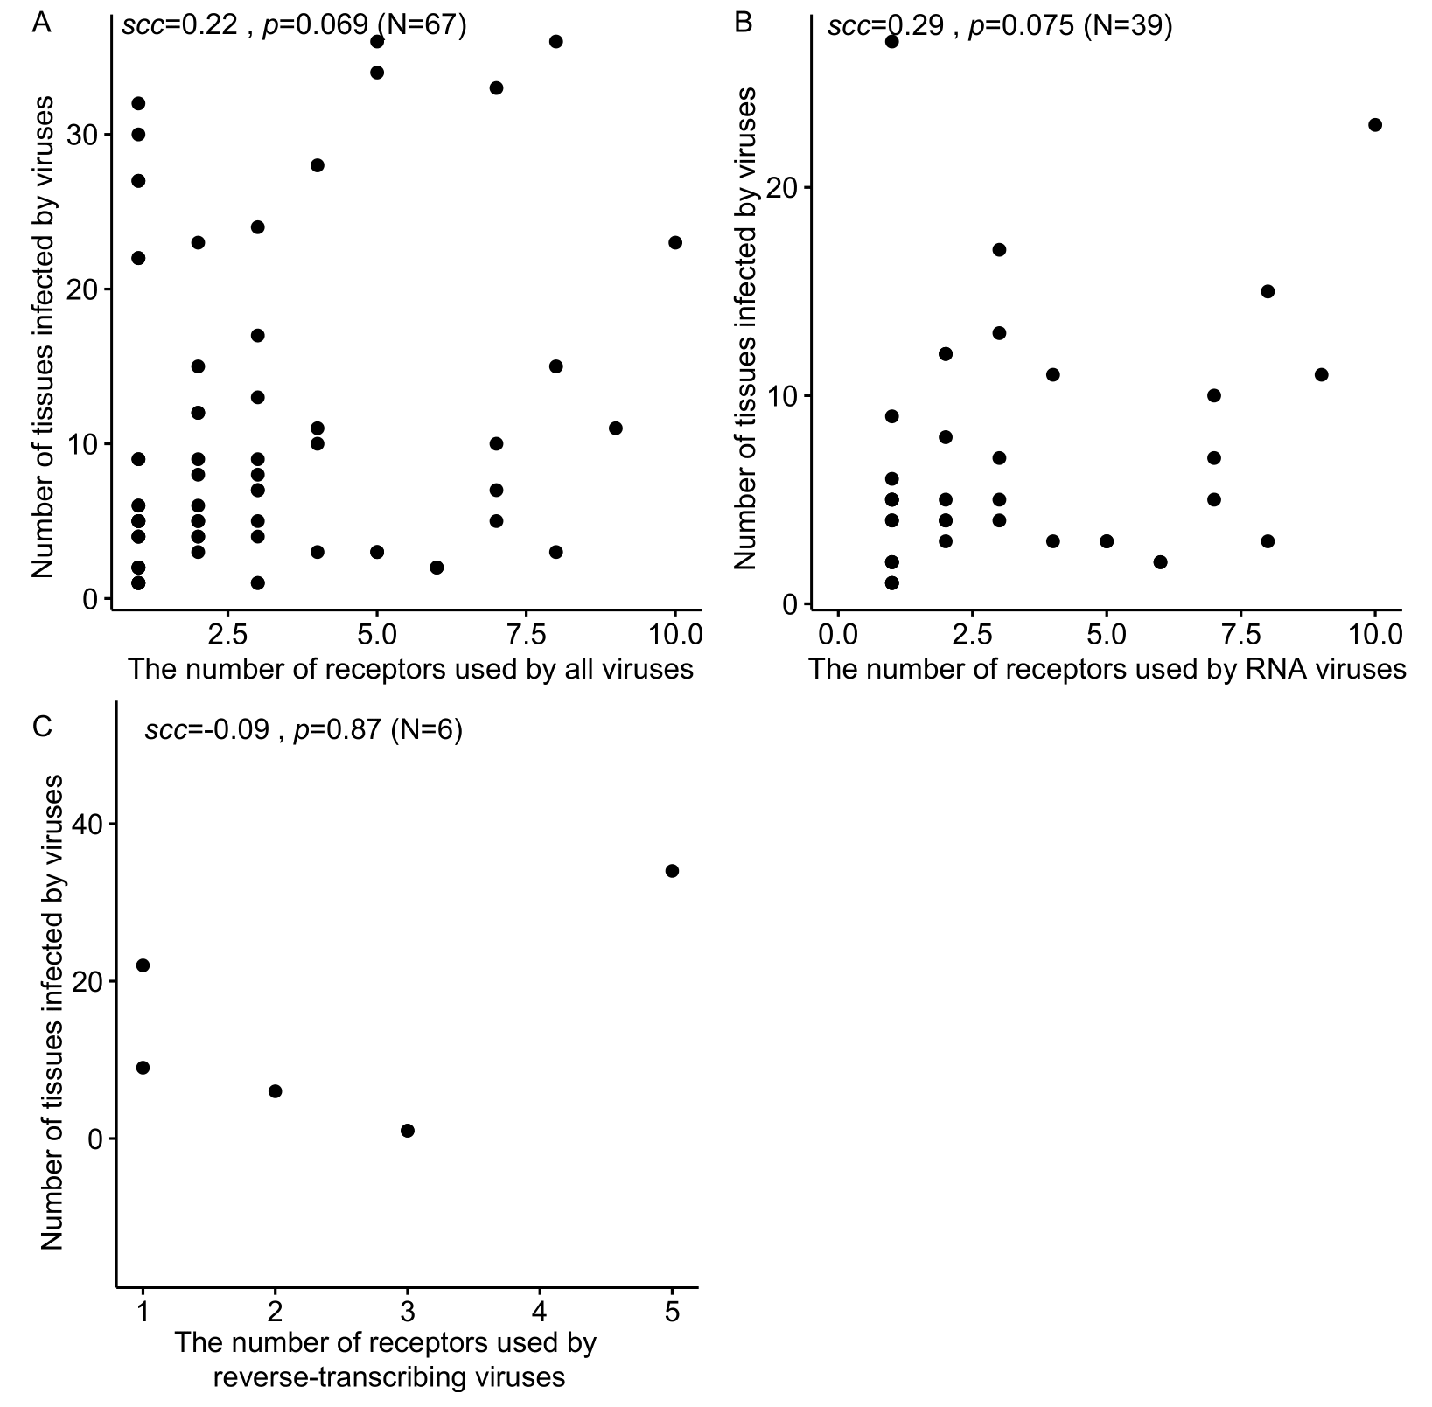

**Figure S9** Comparison of the expression levels of viral receptors in the infected tissues and non-infected tissues. *, p-value < 0.05. N, the number of samples used in the analysis. Only 32 common human tissues were used in the analysis as the gene expression levels were only available in these tissues, and only the viruses infecting at least one of 32 common human tissues were used in the analysis.

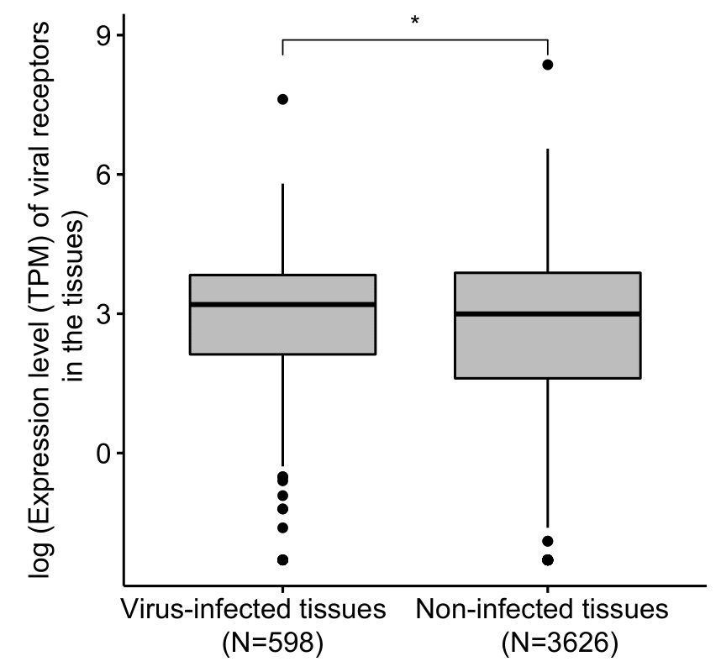

**Figure S10**. The relationship between the number of tissues infected by viruses and the median expression levels of viral receptors used by DNA viruses (A), RNA viruses (B) and reverse-transcribing viruses (C). N, the number of viruses used in the analysis. Only 32 common human tissues were used in the analysis as the gene expression levels were only available in these tissues, and only the viruses infecting at least one of 32 common human tissues were used in the analysis.

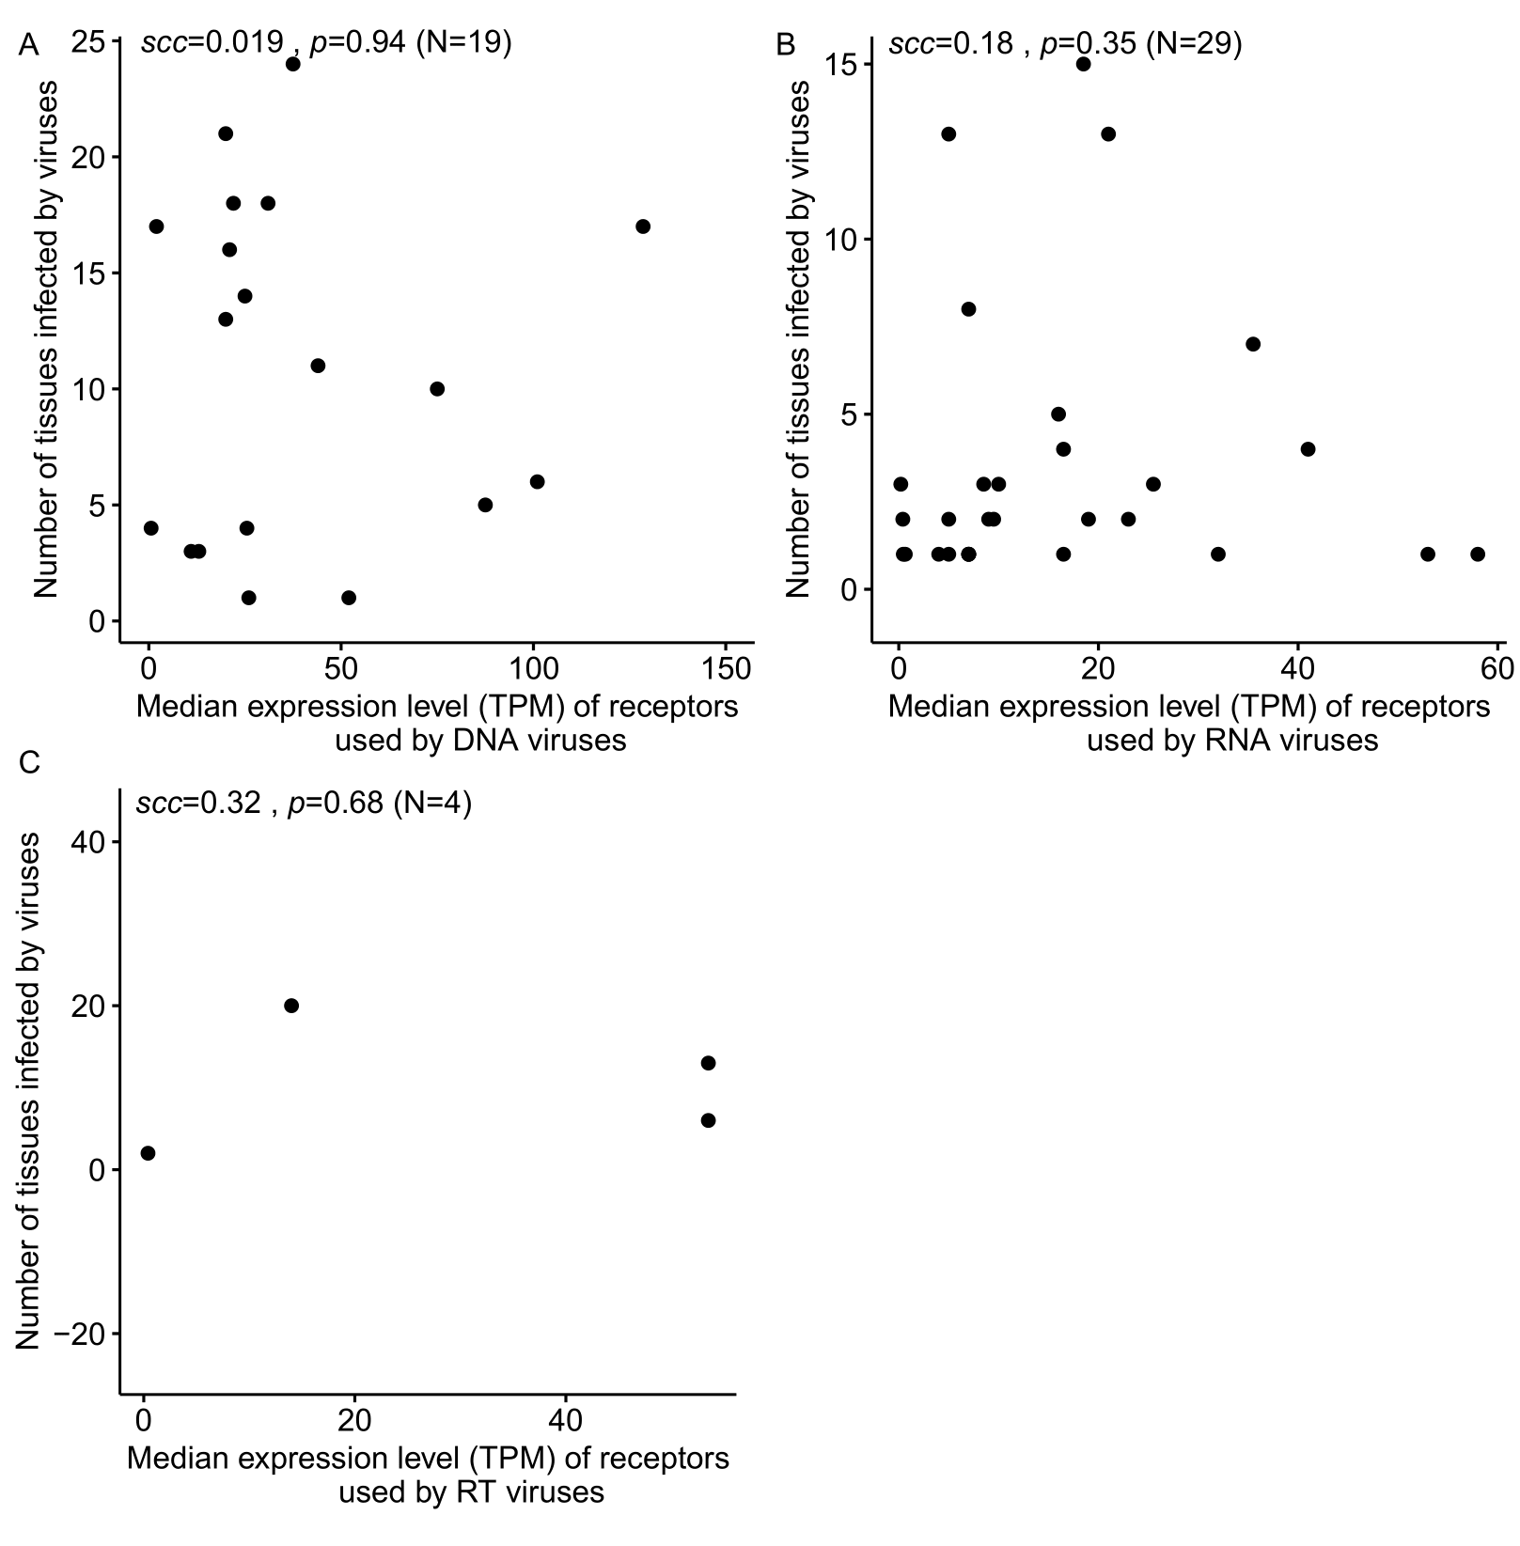

**Figure S11** The relationship between the number of tissues infected by RNA viruses and the median expressions level of VIPs (A), and the median ratio of VIPs (B) in 32 common tissues. N, the number of viruses used in the analysis. Only 32 common human tissues were used in the analysis as the gene expression levels were only available in these tissues, and only the viruses infecting at least one of 32 common human tissues were used in the analysis.

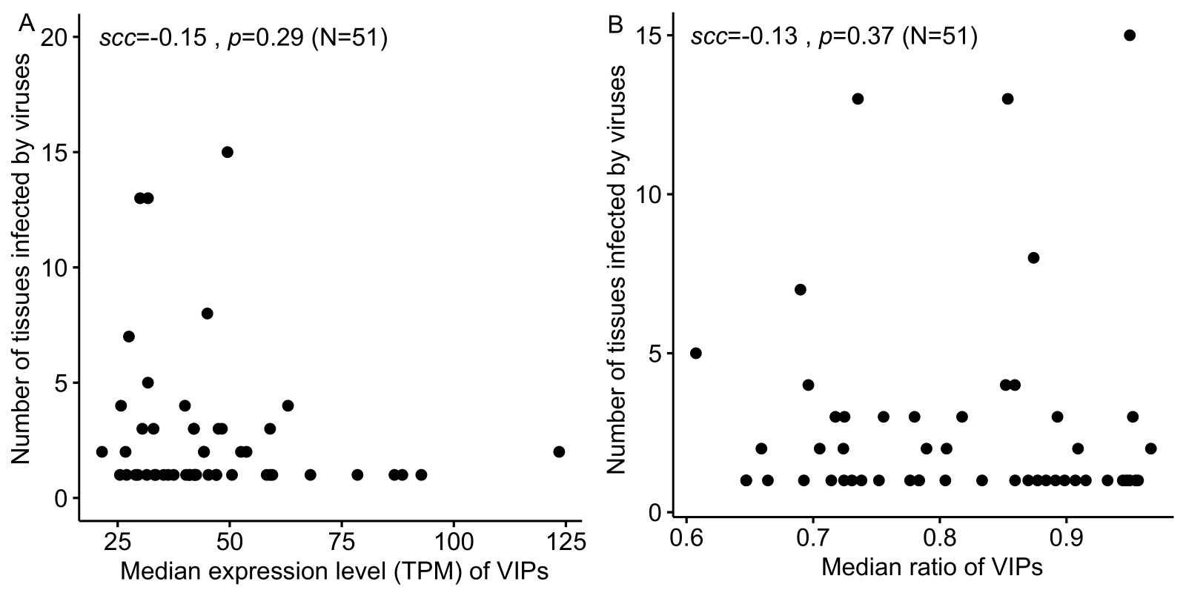

**Figure S12** The relationship between the number of tissues infected by DNA viruses and the median expressions level of immune-related VIPs (A) and non-immune-related VIPs (B), the median ratio of immune-related VIPs (C) and non-immune-related VIPs (D) in 32 common tissues. N, the number of viruses used in the analysis. Only 32 common human tissues were used in the analysis as the gene expression levels were only available in these tissues, and only the viruses infecting at least one of 32 common human tissues were used in the analysis.

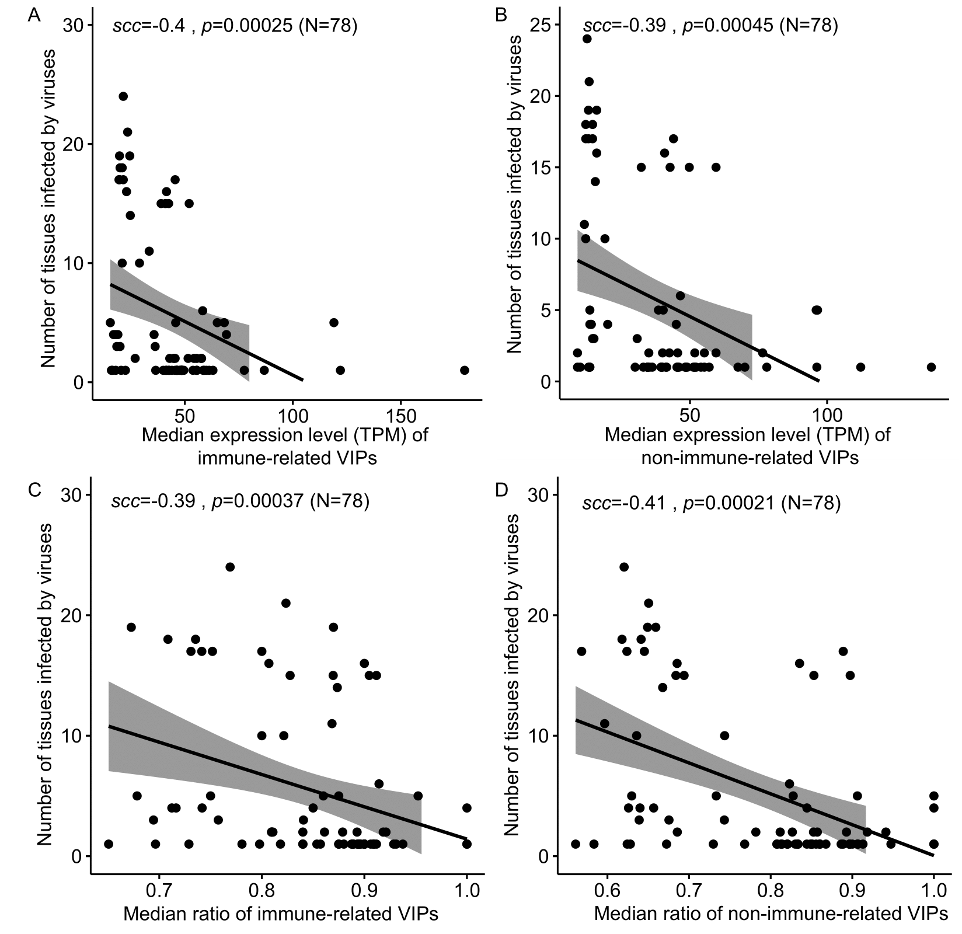

**Figure S13** The relationship between the number of tissues infected by RNA viruses and the median expressions level of immune-related VIPs (A) and non-immune-related VIPs (B), the median ratio of immune-related VIPs (C) and non-immune-related VIPs (D) in 32 common tissues. N, the number of viruses used in the analysis. Only 32 common human tissues were used in the analysis as the gene expression levels were only available in these tissues, and only the viruses infecting at least one of 32 common human tissues were used in the analysis.

